**Uploading to the Arduino Pro Mini using an Arduino Uno SMD**

1. Connect the two boards:

UNO TX - PM TX

UNO RX - PM RX

UNO 5V - PM VCC

UNO GND - PM GND

UNO RST - UNO GND

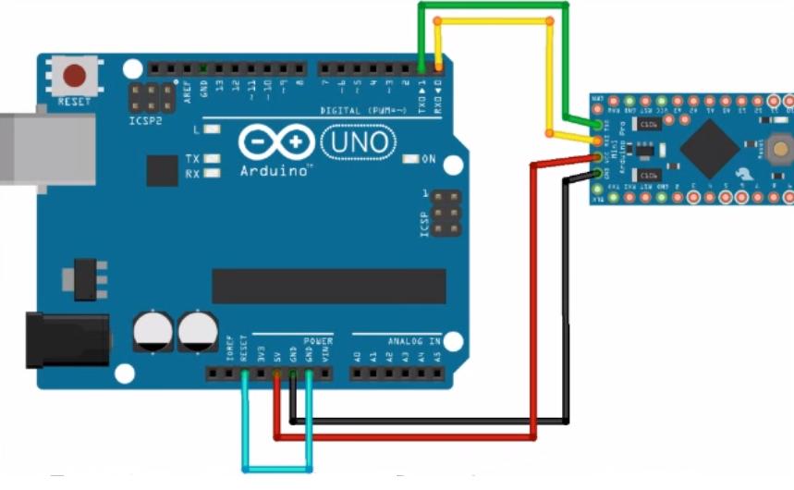

1. Open Arduino sketch and under Tools, select the following settings:

Board: Arduino Pro Mini

Processor: ATMega 328 (3.3V, 8MHz)

Programmer: Arduino as ISP

1. Upload. As soon as ‘Uploading’ is displayed on the IDE, press the reset button on the Pro Mini